**Figures**

**Figure 1: Data structure.** Our study uses a dataset composed of 155 samples. 152 samples have whole-transcriptome RNA-Seq reads, and 105 of them have mass-spec proteomics reads. 103 of the155 samples have both mRNA and protein reads. The data covers four different carbon sources: glucose, glycerol, gluconate, and lactate; and variation for two different ions: i) base and high sodium and ii) low, base, and high magnesium. Collected samples additionally span a two-week interval, which can be divided into 3 growth phases: exponential (Exp), stationary (Sta), and late stationary (Lt.Sta).

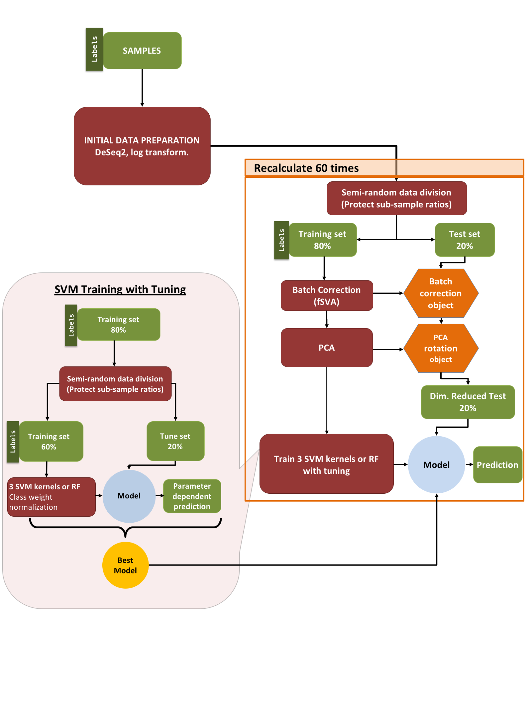

**Figure 2: Machine learning pipeline.** Our pipeline can be separated into three parts. Initial processing, testing loop and tuning loop. After initial preparation, data is semi-randomly (preserving sub-sample ratios) separated into 2 parts: *training&tune* and *test*. After applying fSVA and PCA to the training data, we apply a C-Classification SVM (radial, sigmoidal, or linear kernel) or Random Forest with given class weights that are used to get rid of the penalty on categories with few samples. After obtaining the tuned model we apply the model on test data that is first batch corrected and rotated. During the tuning process the *training & tuning* data is similarly divided into 10 independent *train* and *tune* datasets semi-randomly.

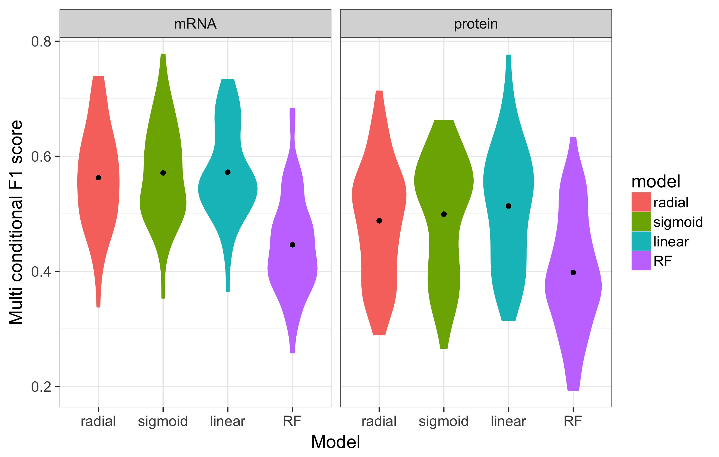

**Figure 3: Performance of complex predictions.** The figures represent the success measured with *multi conditional F1 score* of complex prediction distributions for four distinct models by using their best variables obtained by tuning in each of 60 independent runs on mRNA and protein datasets. Random forest is the worst predictor in both of the cases mRNA is more predictable than proteins. The black dots represent the mean values

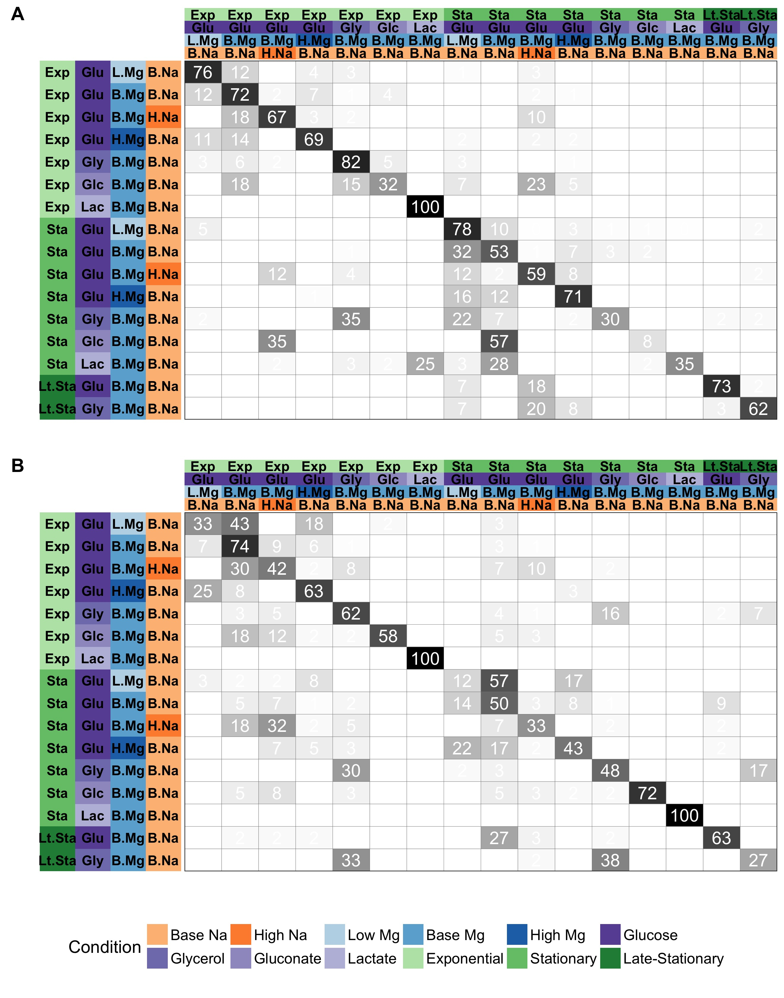

F**igure 4. Predictions of specific growth conditions based on (A) mRNA and (B) protein abundances.** Here we summarize the results of 60 independent runs with SVM using the winning model distributed for 16 distinct conditions. Rows represent true conditions and columns represent predicted conditions. The numbers in the cells and the shading of the cells represent what percent of positive results are predicted as a different condition represented by different columns **A)** SVM with radial kernel is the best performing model in the tuning process with mRNA data where it wins 53 of 60 independent runs and 62.7% of the distributed values are on diagonal line. **B)** SVM with sigmoidal kernel is the best performing model in the tuning process with protein data where it wins 38 of 60 independent runs and 54.3% of the distributed values are on diagonal line.



**Figure 5. Models trained on both mRNA and protein data perform better than models trained on one data type.** The 102 samples for which we have both proteins and mRNA level data are used to compare the performance of machine learning models on only mRNA, only protein, and mRNA & protein data (left to right). Performance increase for combined mRNA and protein data is independent of the used model.The significance of the differences can be found in table 2.



**Figure 6. Overall prediction trends according to the growth phase of the training data.** Summary results for complex predictions for 2 different growth phases exponential and stationary with multiple models. The trends between exponential and stationary phase illustrate the decrease in predictability with increasing time independent from chosen model. The models are trained either on exponential or stationary training samples and tested on corresponding exponential and stationary test samples



**Figure 7. Performance distribution of models for individual tests in intersection data.** The multi-class F1 score of tuned models over “test data”, for four individual conditions: carbon source, growth phase, Mg2+ levels, and Na+ levels. The dataset used in this comparison is only the samples with both mRNA and protein level data.

**Tables**

**Table1:** The winner model distributions out of 60 independent runs in the tuning process for mRNA and protein data with multiple independent runs.

|  |  |  |
| --- | --- | --- |
|  | mRNA | Protein |
| SVM, radial kernel | 53 | 14 |
| SVM, sigmoidal kernel | 6 | 11 |
| SVM, linear kernel | 0 | 22 |
| Random Forest | 1 | 38 |
|  |  |  |

**Table2:** Comparison of *multi conditional F1 scores* generated by using intersection mRNA, intersection protein and combined dataset by using t test. All comparisons are statistically significant after correction for multiple testing. The corresponding distributions can be found in figure 5.

|  |  |  |  |
| --- | --- | --- | --- |
| Model | Comparison | *P* value | Adjusted  *P* value |
| SVM, radial kernel | mRNA vs protein | 1.943E-09 | 4.663E-09 |
| SVM, radial kernel | mRNA + protein vs mRNA | 3.908E-13 | 2.345E-12 |
| SVM, radial kernel | mRNA + protein vs protein | 8.425E-03 | 1.087E-02 |
| SVM, sigmoidal kernel | mRNA vs protein | 3.327E-08 | 6.654E-08 |
| SVM, sigmoidal kernel | mRNA + protein vs mRNA | 3.088E-11 | 1.235E-10 |
| SVM, sigmoidal kernel | mRNA + protein vs protein | 3.517E-02 | 3.517E-02 |
| SVM, linear kernel | mRNA vs protein | 4.728E-11 | 1.418E-10 |
| SVM, linear kernel | mRNA + protein vs mRNA | 1.595E-15 | 1.914E-14 |
| SVM, linear kernel | mRNA + protein vs protein | 9.441E-03 | 1.087E-02 |
| Random Forest | mRNA vs protein | 1.818E-03 | 2.727E-03 |
| Random Forest | mRNA + protein vs mRNA | 1.928E-07 | 3.306E-07 |
| Random Forest | mRNA + protein vs protein | 9.968E-03 | 1.087E-02 |

|  |  |  |  |  |
| --- | --- | --- | --- | --- |
| **A** |  |  |  |  |
| **Samples** | **Na level** | **Mg Level** | **Carbon source** | **Growth** |
| A (Base sample) | base Na | high Mg | Glucose | Exponential |
| B (Glycerol sample) | base Na | high Mg | Glucose | Exponential |
| C (High Na sample) | base Na* | high Mg | Glucose | Exponential |
| D (Stationary phase sample) | base Na | base Mg | Glucose | Stationary* |
| E (Late stationary phase sample) | base Na | base Mg | Glucose | Stationary* |
|  |  |  |  |  |
|  |  |  |  |  |
| **B** |  |  |  |  |
| **Samples** | **Na level** | **Mg Level** | **Carbon source** | **Growth** |
| A (Base sample) | base Na | base Mg | Gluconate | Exponential |
| B (Glycerol sample) | base Na | base Mg | Gluconate | Exponential |
| C (High Na sample) | high Na | base Mg | Glucose | Exponential |
| D (Stationary phase sample) | base Na | base Mg | Glucose | Stationary |
| E (Late stationary phase sample) | base Na | base Mg | Glucose | Stationary |

**Table 3.** The performance of the protein model on external data. A) The gaps on test data is filled by the median values of the training data. B) The training data is trained with the subset of proteins that match with test data. Black cells indicate a correct prediction. The blue cells indicate a prediction in between. The red cells indicate a wrong prediction.